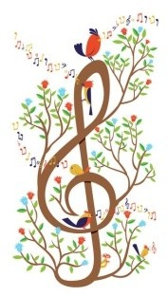
Kidbrooke Park Music Festival 2023

APPLICATION FORM to take part in The Gypsy’s Violin

I would like my son/daughter to take part in the concert with the London Mozart Players and Jeff Moore on Saturday October 28, 2023 at 3pm.

My son/daughter (musician) will also take part in the rehearsal on:
- Friday 27th October 2-5pm and
- Saturday October 28th 12.30 -1.30 pm.

Musician’s Name……………………………………………………

Age ……………

Instrument………………………………………………………

Approximate grade………………

Email address of parent/guardian…………………………………………

Please be aware that orchestra places are limited. A late cancellation of a participant means a missed opportunity for another person, so please help us to avoid this by confirming that your child(ren) will commit to both rehearsals and the concert by ticking this box: ☐

I understand that there will be a charge towards costs of £20 per child, to be paid on application, either in cash or via PayPal using the email address below. ☐

I would like my child to be considered for a TASEG Bursery ☐

Signature parent/guardian………………………………………………

Date……………………………………………..

Please return completed application form by email to
kpmusicfestival@gmail.com

